Used Car Value Prediction

Yang Gao, Yifei Li, Zhuochen Liu, Yuankai Wang, Hao Yang

Nov. 15, 2018

# Abstract

We tried to predict the price of used cars in Poland. We built several models for the dataset provided by user mapik88 on Kaggle (available at [1]). Our final model is a classification model which achieved roughly 80% testing accuracy.

# 1 Introduction

When people want to sell their cars, they want to have an idea about how much their cars worth. A natural approach is to find several similar used cars on the website and look at their price. Unfortunately, since a car’s price can be affected by many factors, it is time-consuming to find similar cars on the internet. Therefore, we would like to build a model for used car prices. Eventually, we found a proper dataset for used car price on Kaggle [1]. The dataset contains various features about used cars, including (but not limited to) the car model, car maker, mileage, and color. Since the dataset has a reasonable size (contains information for more than 200k cars) and covers a lot of features, we decide that this dataset is ideal for training our model.

# 2 Preprocessing

After we downloaded the data and examined it, we found that the data is not well structured for neural networks to train. It contains a lot of empty values, useless features, and meaningless outliers.

The data contained some start times and end times with the same value, which is meaningless, so we deleted those columns. Some of the columns are the identification information of the car, such as the VIN number. These columns are not features of a car, so we also removed them. Some columns have the same value for all cars so they will not affect the output results. We removed these columns to speed up the training process. Some of the columns have the same meaning, such as the year of production and the car age, so only one of them need to be reserved. Some of the features have both a raw classification value column and one-hot encoded columns, so we removed the columns for raw values. We also removed rows that did not contain any data. Some of the rows contain outliers. For example, one of the cars with a poor condition has a price of 3,000,000,000, which we suspect involved money laundering. To get rid of those outliers, we went through the whole dataset using the filter function of excel worksheet and polished the data.

We finally got a dataset of 96582 rows and 97 columns. We uploaded the data to a server and loaded it using python. We picked out the columns that need to be standardized, which include car age, mileage, the number of parameters available, and the number of features. We then one-hot encoded the data that had not been encoded yet and finally got 1106 columns. Before we trained the model, we split the dataset into training and testing data with a ratio of 80% to 20%. For training data, we split it into training and validation sets again with a ratio of 80% to 20%.

# 3 Regression Approach

Our first approach is to train a network that can predict accurate prices. We computed the standard deviation of the price and set it as the baseline. Then, we trained the network using a simple model using Keras with Tensorflow back end. The model had one layer and applied early stopping (patience is set to 3). Initially, we wanted to set the loss of this model as the baseline. However, the training loss and the validation loss are both worse than the standard deviation (shown in picture 1). Even though the loss keeps decreasing, it is not a reasonable model since it does not get better than standard deviation even after 100 epochs. Thus, we decided to keep the standard deviation as the baseline for our future models.

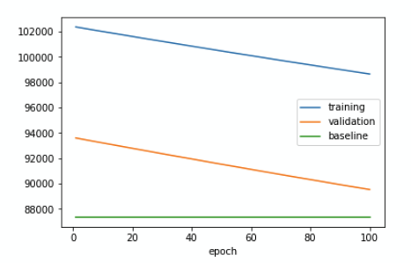

*Picture 1:* The training loss, validation loss and standard deviation for the simple model.

Then, we constructed a more sophisticated model. The model has five hidden layers, and for each layer, there are 10000, 1000, 100, 10 and 1 nodes. To prevent the layers from collapsing, we applied ReLU activation to each layer. We also included early stopping for the model (with patience equals to 3). The network stopped training due to early stopping after 13 epochs. This time, we found that the training loss and validation loss are both smaller than baseline (shown in picture 2). Therefore, we kept this model as the best regression model we trained.

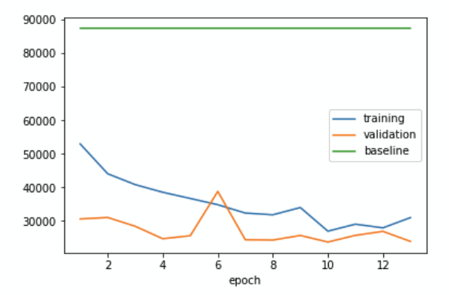

*Picture 2:* The training loss, validation loss and standard deviation for the sophisticated model.

# 4 Classification Approach

We feel that it is hard to determine the exact value of a used car, and because the price of a car is a large number, a small prediction error can lead to a large loss. Besides, the most important thing we want to know is an approximate price range of the used cars. Therefore, we decide to divide cars into six categories according to their prices and build a classification model.

The first categorization method we used is to evenly divide our dataset into six parts and use them to train our new classification model. We decided to use 1% of the original dataset to test the model since we do not want to waste too much time training the huge dataset with an incorrect model. To debug our code, we first tried to drive the training error to zero on this 1% of the data. We tried several models and one of them drove the training error to 0.

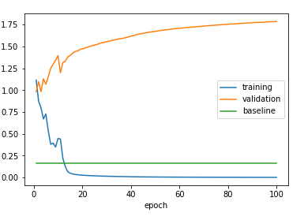

*Picture 3*: The plot of the loss for the model with 1% dataset (see appendix for details)

The training error of 0 showed that this model is correct for the problem. We decided to use this model with regularization for the whole dataset in the following step, and we got an accuracy of about 77% on the testing set.

However, we then realized that the price of a car is not uniformly distributed, so we modified our way to divide the six categories. The new categories are 0-4999, 5000-9999, 10000-19999, 20000-49999, 50000-99999, and greater or equal to 100000. We believe this kind of division system better classifies the quality of cars according to their prices.

The baseline accuracy of this approach is to find out the most common price interval and divide it by the number of all data, which is the accuracy we can achieve by taking random guesses. The baseline accuracy equals 31.76% and our model should perform at least better than the baseline.

Our first model is to simply combine several hidden layers with ReLU activation in between in order to prevent the layer from collapsing, and uses early stopping to prevent overfitting. The validation accuracy for this model is around 77%, which is good for us, but since the training stops at 8th epoch due to overfitting, we want to try to apply dropout to train more epochs and improve the result.

Our final model consists of 5 hidden layers with “ReLU” activation layers in between. The dropout regularization is applied between each pair of layers with a dropout rate of 0.3. The model achieves a validation accuracy of 81.7%, and the accuracy for predicting the test data is 80.7%, which we feel is pretty good.

# 5 Results

Regression model:

For our regression model, since it is hard to compute the exact price of the car, we measured our regression model’s accuracy based on the percentage difference between the predicted price and the actual price. After using the sophisticated model to predict the price for cars in the testing set, we found out that there are around 45% of the predicted values have an error less than 10% and around 74% of the predicted values have an error less than 20%. We also noticed that for some cars, the error rate can be up to 1300%. Due to the poor performance of this regression model, we eventually decided to abandon this model and take the other approach.

Classification model:

We measure our accuracy through not only calculating the ratio of the correctly predicted amount to the total amount of data, but also counting the number of outputs whose classification error is more than two levels away from the actual price level (for example, classified as the second price interval but should actually be the fifth). Here is the final result:

With a total of 19316 pieces of test data, we got:

Number of correct predictions: 15587

Number of incorrect predictions: 3729

Number of incorrect predictions differ by more than 2 levels: 76

# 6 Conclusion

The highest accuracy we have achieved is around 80%. We think this is an acceptable result for our problem. Having a good estimation of the used car price gives people an expectation of how much money they should spend or receive when they buy or sell a used car, which brings them more advantages when they negotiate with dealers or other individuals. The dataset we used is from Poland, but we believe that if we want to estimate the price for used cars in other regions, this model will be suitable as well. The only thing we need to do is to collect more reliable data from the society.

# References:

[1]. mapik88. Used Car Offers, Kaggle, 2018, www.kaggle.com/mapik88/used-car-offers.

Appendix:

**Model And Result for Regression Single Layer Model with one node:**

**(Model):**

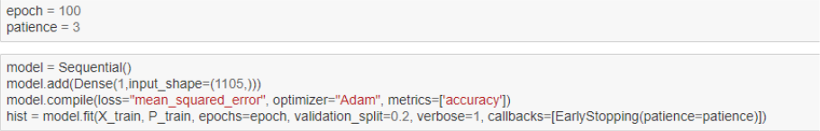

**(Result Summary):**

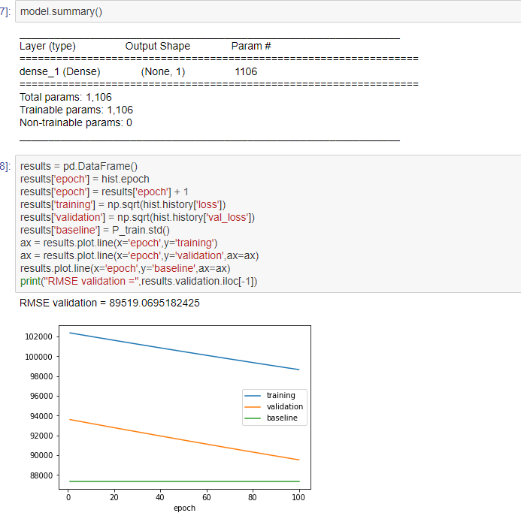

**Model and Result for Improved Regression Model:**

**(Model):**

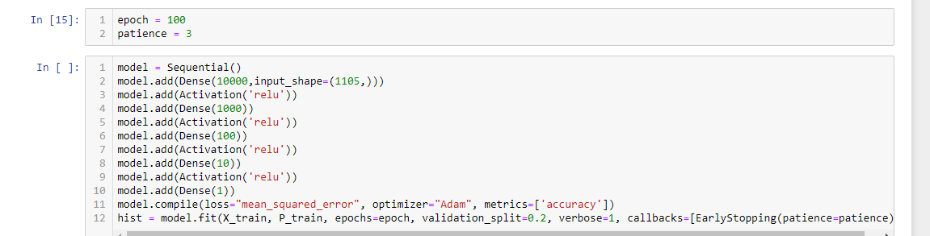

**(Result):**

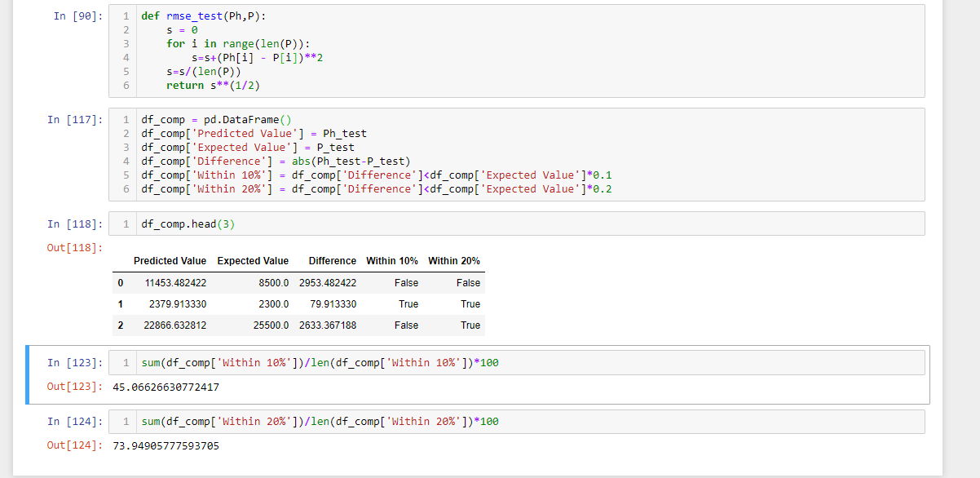

**Model And Result for Classification Model:**

**(Model):**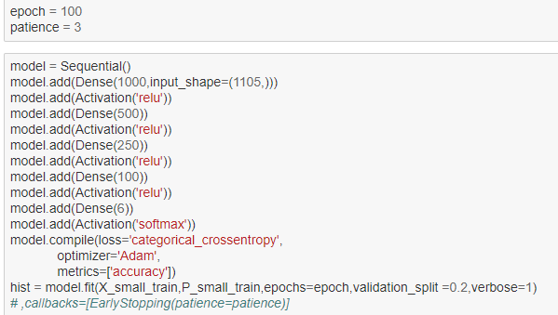

**(Result):**

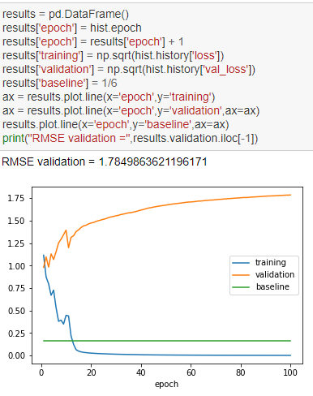

We measure our accuracy not only throw the #corr/#total data but also through identifying #of classification within 2 stages difference(for example, classified as second categories but should be fifth categories). Here is the final result:

Within a total of 19316 test point, we got

correct points: 15587

incorrect points: 3729

number of incorrect points differ by 2 stage: 76